AN EXAMPLE CAN BE FOUND ON MY WEBSITE UNDER THE SKETCHBOOK TAB-SHADING EXCERSICES #3
1. Create a value scale with 6 different values (Dark on the left to light on the right)

2. Shade with smooth transitions from dark on the left to light on the right
3. Shade each shape from dark around the edges to light in the middle (4-6 values

Use the grid method and your ability to shade to copy the image on the left to the right square

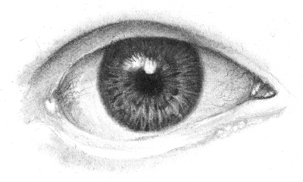
1.

2.

3

